ASSESSMENT FACT SHEET

SUMMATIVE

English Language Proficiency Assessments for California
The English Language Proficiency Assessments for California (ELPAC) is California’s assessment system that is used to determine the English language proficiency of students whose primary language is not English. The ELPAC is aligned with the 2012 California English Language Development Standards and assesses four domains: Listening, Speaking, Reading, and Writing.
WHAT IS THE SUMMATIVE ELPAC? | The Summative ELPAC is given only to students who have previously been identified as an English learner based upon Initial ELPAC results. The Summative ELPAC measures how well they are progressing with English development in each of the four domains.
The purpose of the Summative ELPAC is to measure progress toward English proficiency, to help inform proper educational placements, and to
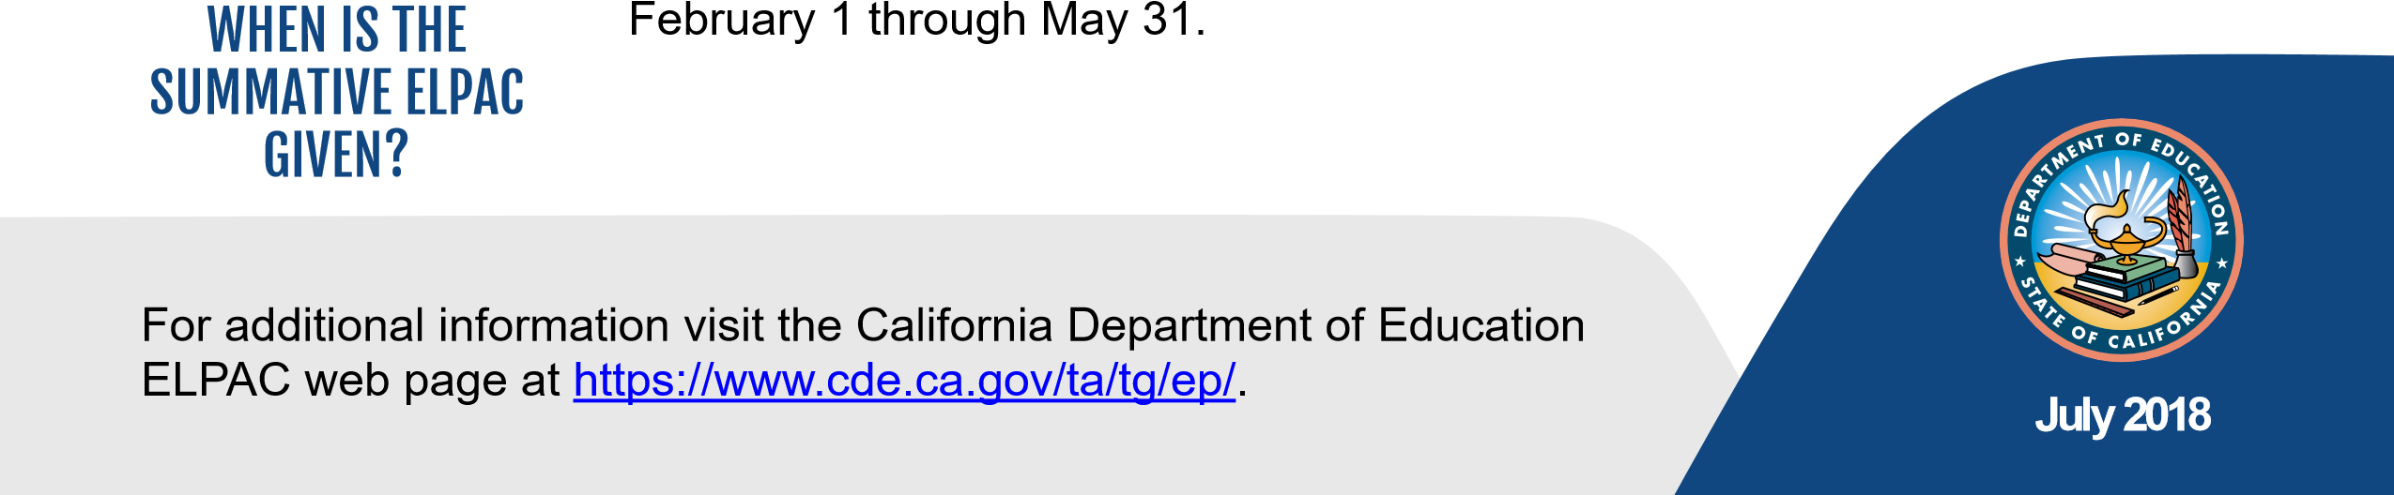
WHY IS THE help determine if a student is ready to be reclassified. This is important when SUMMATIVE ELPAC ensuring that students continue to receive the supports they need to do well
GIVEN? in school.
The Summative Assessment is given only to students in grades K–12 who have been identified as English learners. These students will take the assessment every year until they are reclassified as fluent English proficient.
WHO TAKES THE SUMMATIVE ELPAC? | Students with disabilities who cannot take one or more domains of the ELPAC with allowed universal tools, designated supports, or accommodations will take an alternate assessment(s), as noted in their individualized education program.
The Summative ELPAC is a paper-pencil test administered in seven grade spans—K, 1, 2, 3–5, 6–8, 9–10, and 11–12. In kindergarten and grade
1, all domains are administered individually. In grades 2–12, the test is
HOW IS THE administered in groups exclusive of speaking, which is assessed one-on-one.
SUMMATIVE ELPAC Testing times will vary depending upon the grade level, domain, and GIVEN? individual student. Estimated testing times will be made available on the ELPAC website at http://www.elpac.org.
The Summative ELPAC administration window is open from

